    Name | Shubham Sarang
Roll No | 1345
Topic | Queue
Title of Program | Ordinary Queue

/*
Name: Shubham Sarang
Roll no: 1345
Unit 4: Queue
Program: Ordinary Queue
*/

#include<iostream>
#include<conio.h>
#define MAX 5

using namespace std;

// Queue template

class OQueue
{
int front, rear, a[MAX];
public:
OQueue()
{
front = -1;
rear = -1;
}
void Enqueue(int x);
void Dequeue();
void PeekFront();
void PeekRear();
void Display();
int Full();
int Empty();
};

//Functions

void OQueue::Enqueue(int x)
{
if(Full())
{
cout<<"Queue Overflow!!";
return;
}
if(front == -1)
{
front++;
}
rear++;
a[rear]=x;
}

void OQueue::Dequeue()
{
if(Empty())
{
cout<<"Queue underflow!!";
return;
}
int tmp = a[front];

if(front == rear)
{
front = -1;
rear = -1;
}
else
{
front++;
}
cout<<"Element "<<tmp<<" dequeued";
}

int OQueue::Full()
{
int result = rear == MAX-1 ? 1:0;
return result;
}

int OQueue::Empty()
{
int result = rear == -1 ? 1:0;
return result;
}

void OQueue::PeekFront()
{
if(Empty())
{
cout<<"Queue underflow!!";
return;
}
cout<<"Element at the front: "<<a[front];
}

void OQueue::PeekRear()
{
if(Empty())
{
cout<<"Queue underflow!!";
return;
}
cout<<"Element at the rear: "<<a[rear];
}

void OQueue::Display()
{
if(Empty())
{
cout<<"Queue underflow!!";
return;
}

cout<<"Queue: \n";
for(int i=front; i<=rear; i++)
{
cout<<a[i]<<"\n";
}
}

//Menu

int main()
{
OQueue o;
int num, ch;
while(1)
{
system("cls");
cout<<"***Ordinary Queue***\n\n";
cout<<"1. Perfrom Enqueue on queue\n";
cout<<"2. Perfrom Dequeue on queue\n";
cout<<"3. PeekFront of queue\n";
cout<<"4. PeekRear of queue\n";
cout<<"5. Display queue\n";
cout<<"6. Exit\n\n";
cout<<"Enter the choice you've made: ";
cin>>ch;
switch(ch)
{
case 1:
cout<<"Add Element: ";
cin>>num;
o.Enqueue(num);
getch();
break;
case 2:
o.Dequeue();
getch();
break;
case 3:
o.PeekFront();
getch();
break;
case 4:
o.PeekRear();
getch();
break;
case 5:
o.Display();
getch();
break;
case 6:
exit(1);
default:
cout<<"Wrong option bruv";
getch();
break;
}
}
}
Output:
Menu:
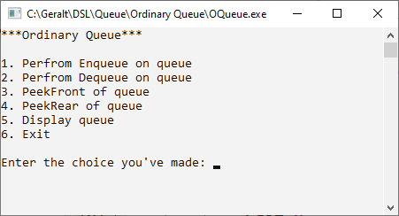
Enqueue:
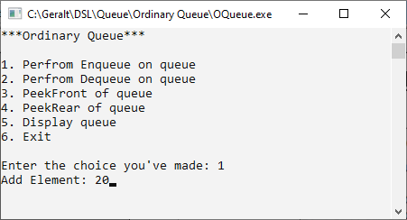
Queue overflow:

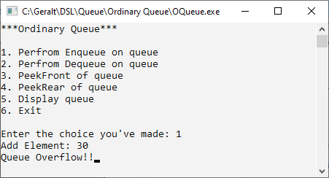
Dequeue:
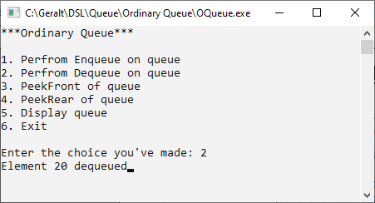
Queue:
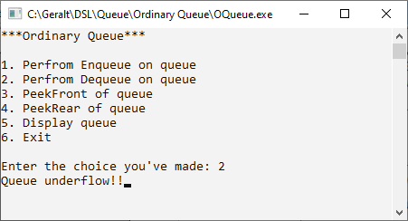
PeekFront:
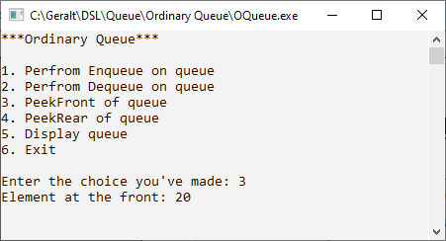
PeekRear:
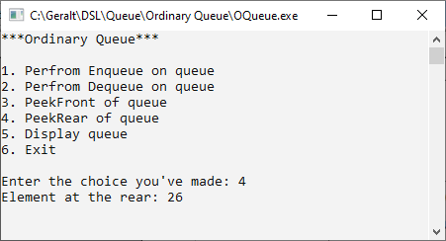
Display:
